SHREYAS SARKAR
B.Tech in Artificial Intelligence | Techno India University, Kolkata
Kolkata, West Bengal | +91-9XXXXXXXXX | shreyas.sarkar@email.com | linkedin.com/in/shreyassarkar
_____________________________________________________________________________________
PROFESSIONAL SUMMARY
Motivated B.Tech Artificial Intelligence student (3rd Year) at Techno India University, Kolkata (ID: 231003003193), with certified skills in Python for Data Science, Python for Beginners, and ChatGPT & AI Learning. Completed virtual internship with Grade A and Entrepreneurship Skill Development Program. Seeking an entry-level role / internship in Data Science, AI, or Python Development.
EDUCATION
- B.Tech in Artificial Intelligence - Techno India University, Kolkata | 2023-2027 | 3rd Year | ID: 231003003193
- TIU_BTECH-AI | Cohort 2
TECHNICAL SKILLS
- Programming: Python, SQL (Basics), HTML/CSS
- Data Science & AI: Pandas, NumPy, Data Visualization, Prompt Engineering, ChatGPT & Generative AI
- Tools: Jupyter Notebook, VS Code, Git & GitHub, Google Colab
INTERNSHIP
Virtual Intern - ChatGPT & AI Learning | Techno Billion AI - 17 Feb 2026 - Grade A
- Completed virtual internship demonstrating consistent learning and strong understanding of AI concepts. Certificate ID: a798de44-0285-4f27-8362-b791ba97d02a
CERTIFICATIONS
- Python for Data Science - Techno India Education - 7 June 2026 - ID: C332E0E634814457
- Python for Beginners - Techno India Education - 7 June 2026
- ChatGPT & AI Learning - Virtual Internship Grade A - Techno Billion AI - 17 Feb 2026 - ID: a798de44-0285-4f27-8362-b791ba97d02a
- Entrepreneurship Skill Development (ESD) Program - Techno India University - Cohort 2 - 23 June 2026 - ID: CERT-2025-26-TIU-BTECH-AI-M3NJNY
CERTIFICATES - WITH PROOF
Attached below are the scanned copies of all 4 certificates for verification:
Python for Data Science - Techno India Education - 7 June 2026 - ID: C332E0E634814457
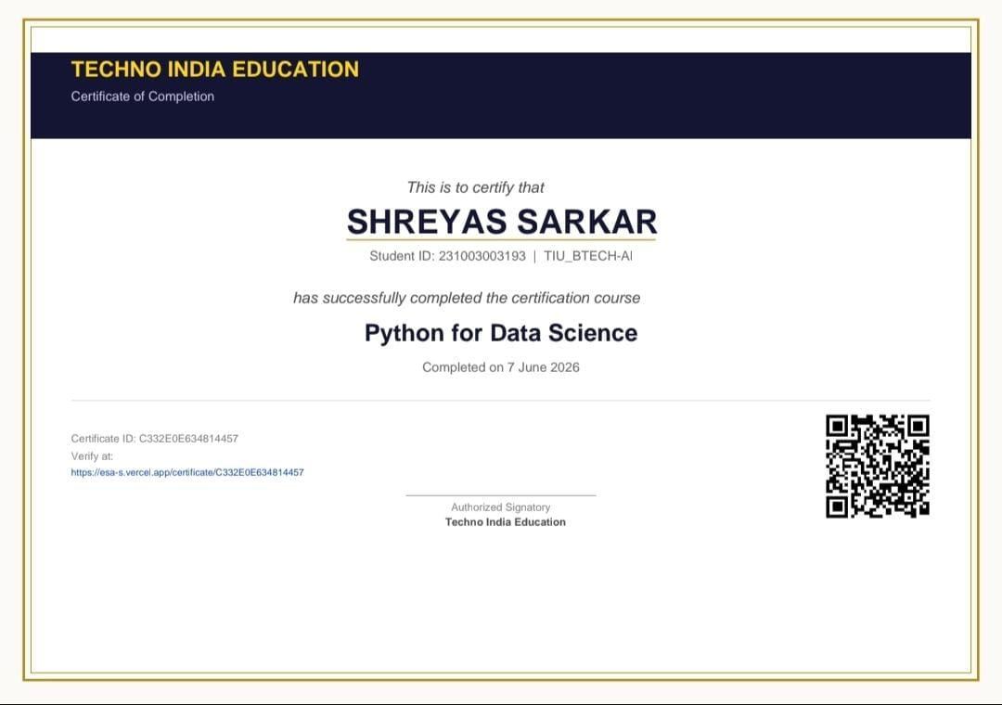
Python for Beginners - Techno India Education - 7 June 2026
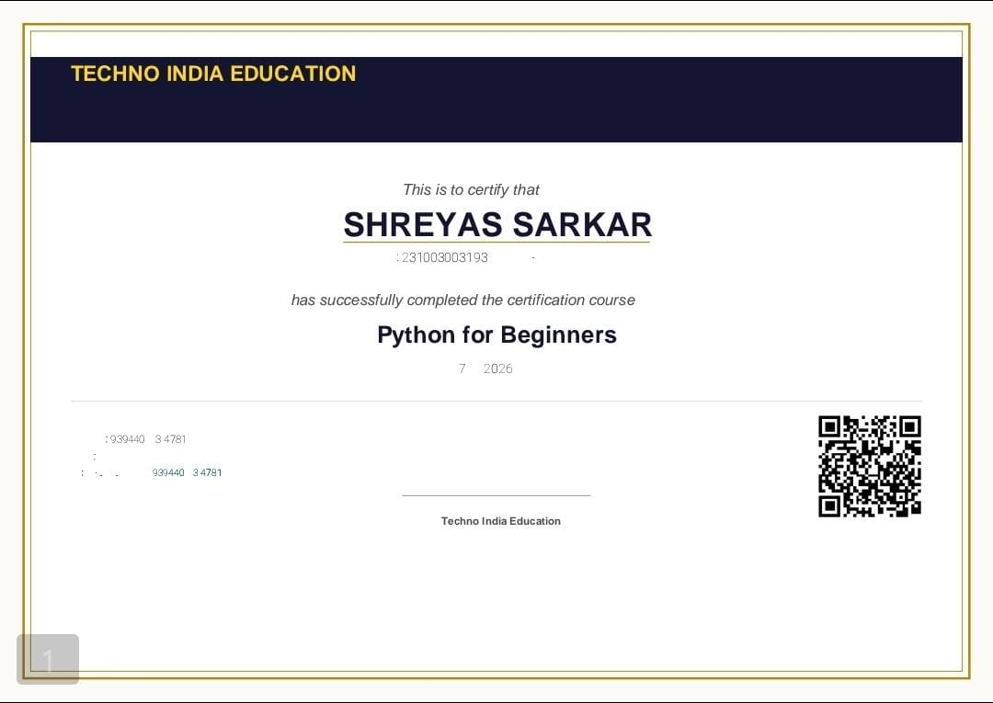
ChatGPT & AI Learning - Virtual Internship Grade A - Techno Billion AI - 17 Feb 2026 - ID: a798de44-0285-4f27-8362-b791ba97d02a
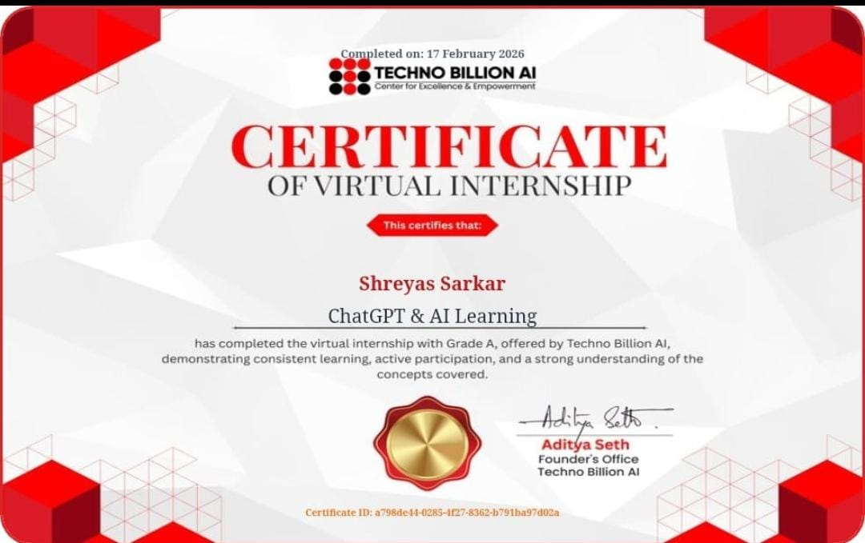
Entrepreneurship Skill Development (ESD) Program - Techno India University - Cohort 2 - 23 June 2026 - ID: CERT-2025-26-TIU-BTECH-AI-M3NJNY
